C Programming
Programming Language:
Medium of communication between humans and computers.
Instructions to computer to perform specific tasks.
Acts like bridge between humans and machine.
Why Programming:
Communicate instructions to computer.
Automate complex calculations and tasks.
Repetitive tasks.
To solve real world problems.
Control hardware.
Types of programming languages:
1.Low level languages:
(very close to hardware)
i. Machine Language:
First generation Language(1GL)
native lang of computers
Binary ( 0’s and 1’s)
ii. Assembly language(Symbolic Programming Language):
Second generation language(2GL)
Requires Assembler - converts Assembly lang to Machine lang.
Uses alpha-numeric symbols called as mnemonic codes(MOV,ADD,…)
2.High level languages:
(user friendly)
Third generation language(3GL)
Uses natural language elements eg. English like syntax
Easier for humans to understand and maintain code
Requires compiler or interpreter
Types of high level languages:
a)Algebraic Formula-Type Processing:
BASIC (Beginners All Purpose Symbolic Instruction Code).
FORTRAN (Formula Translation).
b)Business Data Processing:
COBOL (Common Business Oriented Language).
RPG (Report Program Generator)
c)Procedural:
C,Pascal,Fortan,Cobol……..
d)OOP(object oriented programming):
C++,Java,Python…

Language Translators: (system software)
Converts high level language into low level language(machine lang).
i. Assembler (assembly lang to machine lang)
ii. Compiler (c,c++,java…)
iii. Interpreter (python,ruby,JavaScript…)
C Programming:
Dennis Ritchie in 1972 at bell labs.
Designed to create system software like operating systems.
Created to develop Unix operating System.
Standardised by ANSI in 1989.
Successor of B language.
Features of C language:
High level lang (as well as low level lang)
Small language - 32 keywords easy to learn
Portable- can run on different machines
Machine independent- Source code is independent of hardware architecture
Platform dependent- Compiled executable code depends on the operating system
Faster compilation and execution
Procedural- sequence of actions or steps to solve a problem
Structural- organizes code into clear, logical modules and blocks
Pointers- Provides direct memory access and manipulation
Case sensitive- Distinguishes between uppercase and lowercase identifiers
Built in functions- pre-defined Standard library functions (I/O, math, string handling)
Extensible Language- Programmers can add new functions and features
Modular Programming- Large programs can be divided into smaller modules/files/func
Dynamic Memory Allocation- Allows runtime memory management using malloc(), calloc(), free()
General Purpose - Wide application scope, suitable for system programming (OS, s compilers) and application programming (games, databases)

Applications:
Design system software and application software
Operating system-Linux,UNIX
Compilers-c++,java,python
Databases-Mysql,oracle database
Text Editor-Vim,GNU nano,windows Notepad
Embedded Systems- Arduino firmware, Raspberry Pi OS components
Device Drivers and Network Drivers
Game Development- Counter-Strike (engine parts)
Microprocessors- Intel processors, ARM-based chips
Gui Applications-Adobe Photoshop, Mozilla Firefox
Spreadsheets-Microsoft Excel

Compilation process of c program:
1.Preprocessor: .c -> .i
2.Compiler: .i -> .s or .asm
3.Assembler: .s -> .o or .obj
4.Linker: .o -> .exe or .out

Steps to Execute c program:
1.Text editor:
Writing and editing the program using Text editor (source code).( .c file)
2.Compiler:
Compile the program: (Command: gcc prg.c -o prg for gcc compiler.)
Checks for errors-syntax and semantic.
It generates object code after compilation . (.obj file)
3.Linker:
It links the library functions/header files to the program i.e. to obj code.
It generates executable file.(.exe file)
4.Loader:
Process of transferring program(.exe) from secondary storage to main memory
for execution. (Running Command: ./prg or ./a.out)
For every program there will be 3 files. ( .c file , .obj file, .exe file )

General Structure of a C program:
1.Documentation section (optional) (compiler does not execute this section)
Comments (brief description)- Used to describe the program, author, purpose,date etc.,
i.single line - //
ii.multi line - /* ………………
………………….*/
2.Link section- Includes header files before compilation.
#include <lib> - ( #include<stdio.h> , #include”conio.h” )
# - preprocessor .h - header files (contains declarations not funcs)
stdio - standard input output
-(contains printf(),scanf(),fopen(),fclose(),puts…. functions).
conio- console input output(contains getch,clrscr,…. functions).
3.Definition section (optional)
Defines symbolic constants and macros(preprocessor directives) using #define.
#define const_name value -macros does not allocate memory in RAM.
#define square(x) (x*x)
4. Global declaration section (optional)
Declares global variables accessible throughout the program.
int x; //global var
5.Main function section- the entry point of every program in c.
main() (Only 1 main function )
{ Declaration part
Executable part (statements)
}
6. Sub-program section (optional) - User-defined functions for modularity & reusability.
Data_type function_name()
{ Statements;
return value;
}
Semicolon(;) – statement terminator (Every line ends with semicolon.)
Tokens: smallest individual units in a program.
1. Variables
2. Identifiers
3. Keywords
4. Constants
5. Data Types
6. Operators

1.Variables : names given to the memory location that is used for storing data.
Syntax : Data_type variable_name;
Eg: int x,y;
float a=10.5;
When a variable is declared it contains undefined value commonly known as garbage value.
A variable can be declared only once in same scope.

2.Identifiers: Identifiers are user defined words that are used to give names to entities like variables, arrays, functions, structures etc.
Eg: int age;int array[10];
Rules:
i.contains alphabets(A-Za-z),digits(0-9) and underscore(_).
ii.cannot start with digit.
iii.no special symbols except underscore.
iv.should not be keyword.

3.Keywords:
These are the reserved words have fixed meaning.
Keywords serve as basic building blocks for program statements.
All keywords must be written in lowercase. C contains 32 keywords.
auto break case char const continue default do double enum else extern float for goto if int long return register signed short static sizeof struct switch typedef union unsigned void volatile while

4.Constants or Literals: (fixed value)
Constant is a value that cannot be changed during execution of the program.
i.integer
Integer constants may be suffixing with I or L( for long), u or U (for unsigned), ul or UL (for unsigned long)
• decimal constant(base 10)
a) Decimal Integer value which consist of digits from 0-9.
b) Decimal Integer should not prefix with 0.
• octal constant(base 8)
a) it consist of digits from 0 to 7.
b) It should prefix with 0.
• hexadecimal constant(base 16)
a) It consist of digits from 0-9,a-f(capital letters & small letters).
b) it should prefix with 0X or 0x.
ii.real or floating point
constants that contain decimal point. (mantissa e exponent)
the number is written in the mantissa and exponent form, which are
separated by ‘e’ or 'E'.
By default the type of a floating point constant is double.
Suffix with f or F (for float type), I or L ( for long double).
iii.character(‘ ’)
constants contain single character enclosed within single quotes.
Also include backslash characters/escape sequences.
Ascii codes:
A-Z = 65-90
a-z = 97-122
0-9 = 48-57
Backslash characters/Escape Sequences:
\n newline
\r carriage return
\t tabbed space(4)
\v vertical tab
\b backspace
\a alert (beep)
\’ single quote(‘)
\’’ double quote(‘’)
\? Question mark (?)
\\ backslash (\)

iv.string(char [] or char *)(“ ”)
constants are enclosed in double quotes "".
NULL(‘\0’)- Ascii Value - 0
a string is an array of characters terminated by a NULL character.
Two ways to define constant in C
- const keyword
Syntax:
const type variable = value;
eg. const int x=10;

- #define preprocessor
Syntax:
#define identifier value
Use identifiers always capital
eg. #define MAX 100
5.Data Types:
specifies the type of data that a variable can store.
Three types:
1.Primary or Basic or Primitive Data types
-int,float,double,char,void
2.Derived Data types
-array,structure,union,pointer
3.User Defined Data types
-typedef,enum
Qualifiers:
Size Qualifiers-short , long.
Sign qualifiers-signed(default) , unsigned.
For 16 bit machine.

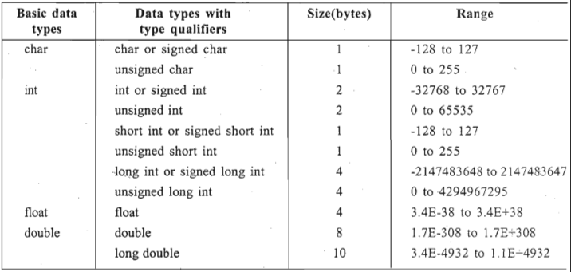

Format Specifiers:
%c - a single character
%d - a decimal integer
%f,%g,%e - a floating point number
%If - double data type
%Lf - long float
%h - a short integer
%l - long
%o - an octal integer
%x - a hexadecimal integer
%i - a decimal, octal or hexadecimal integer
%u - an unsigned decimal integer
%s - a string

Range of data types:
For a n- bit signed integer:
Range is -2^{(n-1)} to 2^{(n-1)}-1
For a n- bit unsigned integer:
Range is 0 to 2^{n}-1
Data units:
1bit – 0 or 1
1 Nibble - 4 bits
1 Byte - 8 bits
1 Kilobytes - 1024 bytes
1 Megabytes- 1024 kb
Storage classes:
auto , register , static , extern .

6. Operators:
Symbols that perform operations.
Types:
1.Arithmetic operators:
+ Addition
- Subtraction
* Multiplication
/ Division
% Modulus(remainder) -only for int (+/- a%b takes sign of a)
2.Relational operators: (used for int,float,char) (for strings -unspecified behaviour)
-returns 0 (for false) or 1 (for true).
< less than
> greater than
<= less than or equal to
>= greater than or equal to
== equal to
!= not equal to
3.Logical operators:
-returns 0 or 1.
&& - logical AND
|| - logical OR
! - logical NOT
4.Assignment Operators: (precedence- Right to left)
-used for assigning values.
= a=b
+= a=a+b
-= a=a-b
*= a=a*b
/= a=a/b
%= a=a%b
5.Increment and decrement operator/Unary operators: ( for int,float,char)
++ Increment
-- Decrement
++x Pre increment
- -x Pre decrement
x++ Post increment
x-- Post decrement
6.Bitwise Operators: ( for int only)
& - Bitwise AND
| - Bitwise OR
~ - Bitwise NOT ( ~a = -(a+1) ) 2’s complement)
^ - Bitwise XOR
<< - left shift ( a<<b = a*2^{b} )
>> - right shift ( a>>b = a/2^{b})
7.Conditional or Ternary Operator:
? : conditional operator (likewise if else)
Res=TestExpression ? expression1 : expression2
If test exp is true res=exp1, else res=exp2.
8.Special operators:
Comma,sizeof(),*,&,->,.
Comma(,):
- int a,b,c; //separator
ii) int a=4,5; //error ,at declaration it is separator.
iii) int a;
a=4,5; //a=4 because right operand of comma has no effect.
iv) int a =(f1,f2,f3); or
int a;
a=(f1,f2,f3) // a=f3, but f1 and f2 is evaluated.
Sizeof operator:
-returns size in bytes of variable,constant or datatype.
-sizeof(variable_name);
& - Returns the address of a variable &a;
* - Pointer to a variable. *a;

Operator Precedence Table:

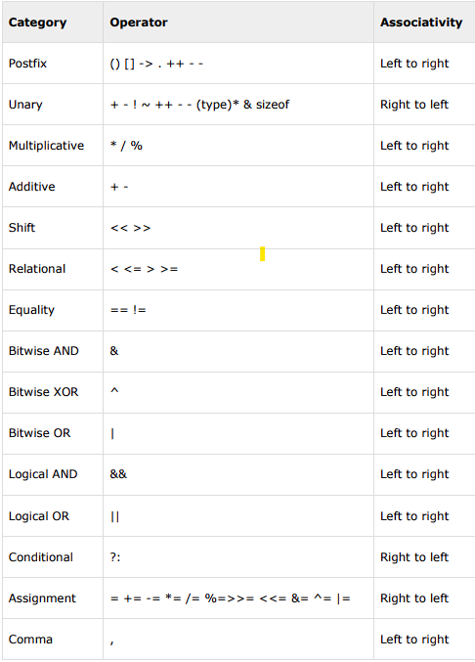

Formatted Input and Output:
Input:
scanf():
Syntax : scanf(“control string “,&var1, &var2,………, &var_n);
The (&) symbol gives the meaning “address of “ the variable.
It returns number of inputs read by func.
Control string contains format specifiers,width,conversion flags,delimiters…..
Eg:
scanf(“%d %d”,&a,&b); scanf(“%2d %3d”,&a,&b);
scanf(“%d-%d-%d”,&a,&b,&c); scanf(“$%d”,&a);
Output:
printf():
Syntax : printf(“control string “, var1, var2, …………, var_n);
It returns number of characters printed.
Eg:
printf(“Hello world”); printf(“%d”,a);
printf(“Sum is %d”,a); printf(“%.2f”,a);
printf(“%8d”,1234); // ----1234
printf(“%-8d”,1234); //1234----
printf(“%08d”,1234); //00001234
printf(“%8.2f”,12.345); //--123.34
Unformatted Input and Output:
Input:
getchar()
getch()
getche()
gets()
Output:
putchar()
putch()
puts()

Control Statements:
1.Conditional/Branching/Selection statements:
if , if-else , nested if-else , if -else if-else ,switch
2.Looping/Iteration Statements: for , while , do-while
3.Unconditional/Jump statements: break , continue , goto

1.Conditional statements:
i. if statement: //for single line { } – not required.
Syntax: if(condition){
//statements;
}

ii.if -else statement:
Syntax: if (condition){
//statements;
}
else{
//statements;
}

iii.nested if -else:
Syntax:
if(condition){
if(condition){
//statements;
}
else{
//ststements;
}
}

iv.

